**KWORUS SECONDARY SCHOOL**

**P.O BOX 121 KAPCHORWA-KWEEN.**

[**TEL:0777253593/0777146352**](TEL:0777253593/0777146352) **or Email:kworusss@gmail.com**

**EOT ONE S.3 GEOGRAPHY 2024**

**Instructions: Attempt one item. TIME 1hour**

**Item 1**

Uganda has always been exporting at least 400,000 tons of maize to Kenya annually. On 5th/March/2012, Kenya imposed a total ban on importation of maize from Uganda citing high level of aflatoxins which make maize unfit for human and animal consumption. This led to a surplus of maize in Uganda, which caused a reduction in prices, low consumption resulting into wastage.

**Support materials**

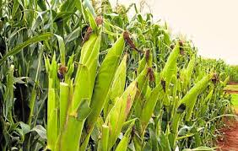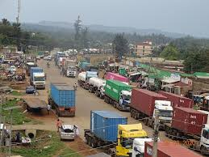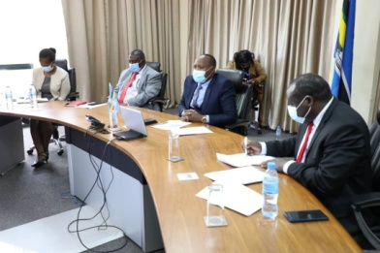

**Task**

You are the minister of trade and industry for Uganda and you have been tasked to intervene. Write a report to the two governments.

**Item2**

Mining areas can be a bee hive of activities. Bungkhokho a remote village in East Africa is endowed with resources like minerals, forests and streams. This enables the local people to carry out many activities as a basic source of income to support their livelihood. Investors have set up ore processing factory near the mining centre’s which are a threatening the environment. A section of the local people has come up to decompaign mining activities.

**Support material**

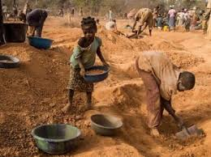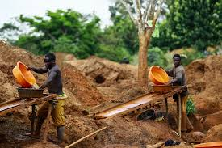

**Task**. Organize a sensitization message of 200-250 words you will present at a meeting.

**End**